Ideation Phase
Brainstorm & Idea Prioritization Template

Date | 1 November 2025
Team ID | NM2025TMID05413
Project Name | Educational Organisation Using ServiceNow
Maximum Marks | 4 Marks

Brainstorm & Idea Prioritization Template:
Educational Organization using ServiceNow Template:
This guided project focuses on developing a centralized Educational Organization Management System using ServiceNow. The project aims to digitize and automate academic processes such as student registration, faculty management, course tracking, and feedback collection — all within the ServiceNow platform.
Use this template in your own brainstorming sessions so your team can unleash their imagination and start shaping concepts even if you're not sitting in the same room.
Reference: https://www.mural.co/templates/brainstorm-and-idea-prioritization
Step 1: Team Gathering, Collaboration, and Problem Statement Selection
Team members collaborated to identify real-world challenges in educational institutions. The chosen problem statement was how to digitally manage an organization’s academic and administrative processes using ServiceNow. The discussion emphasized creating a unified platform for students, faculty, and administrators to interact seamlessly.
Reference:https://www.mural.co/templates/brainstorm-and-idea-prioritization

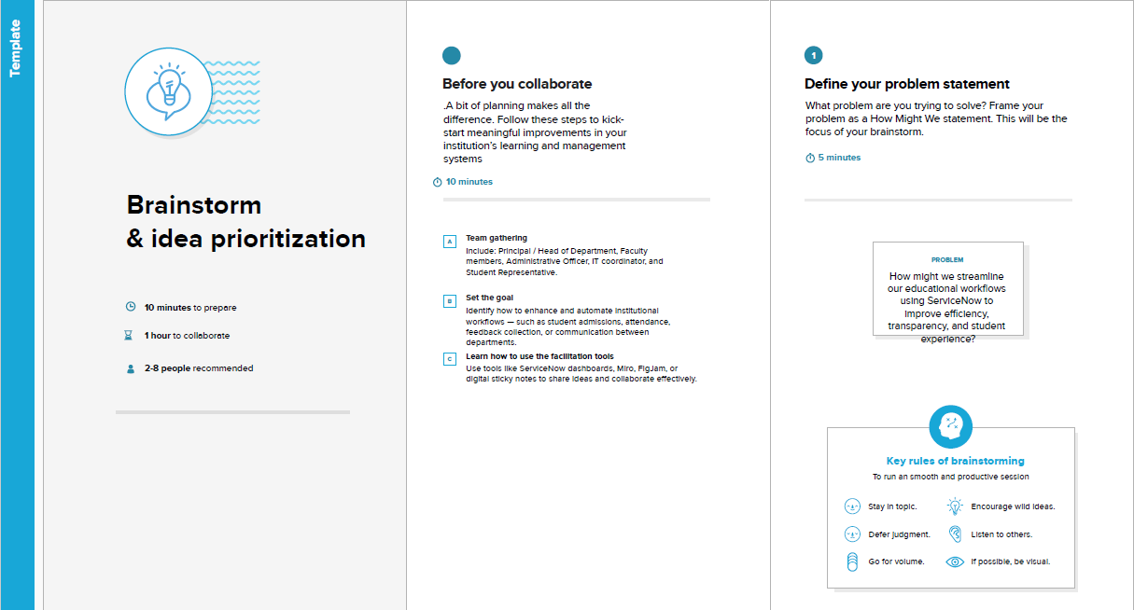

Step 2: Brainstorming, Idea Listing, and Grouping
Brainstorm:
Team members collaborated to identify major challenges faced by educational institutions in managing administrative and academic processes. Ideas focused on automating workflows, improving accountability, enhancing transparency, and ensuring efficiency through ServiceNow tools such as Flow Designer, Catalog Items, and Workflows.
Idea Listing:
Multiple ideas were gathered during the brainstorming session, including:
- Automating student admission and approval processes.
- Assigning academic and administrative tasks based on staff expertise.
- Tracking workloads like course schedules, exam duties, and student requests.
- Simplifying feedback collection and improving internal transparency.
Grouping:
After collecting ideas, the team organized them into four key clusters:
- Cluster 1: Automate student admission workflows using ServiceNow forms and real-time approval routing.
- Cluster 2: Assign academic or administrative tasks based on staff roles, departments, and expertise for better accountability.
- Cluster 3: Track and balance workloads like course scheduling, exam duty allocation, and student requests using dashboards and analytics.
- Cluster 4: Improve transparency and efficiency by simplifying internal processes and gathering regular feedback from staff and students.
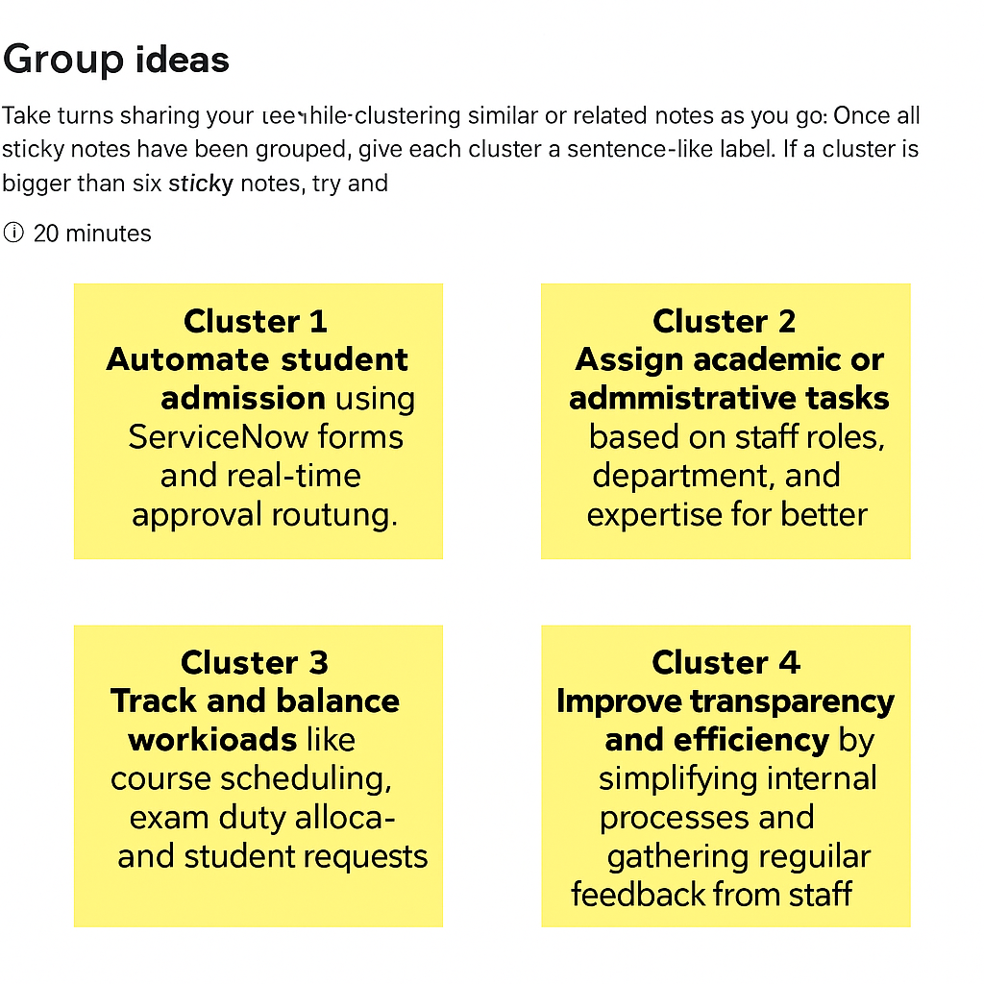

Step-3: Idea Prioritization
Prioritization focused on implementing the most impactful modules first — Student Management and Course Management. These form the foundation of the educational system.
This structured prioritization allows the team to gradually expand functionalities such as feedback automation, performance tracking, and analytics dashboards. Visual representations and flow diagrams help ensure clarity during development and communication among stakeholders.
By organizing ideas based on educational relevance, feasibility, and user impact, the project achieves its goal of building a complete educational management ecosystem using ServiceNow.

